Grassland Management School
Field Days
July 27th OR July 28th
One day workshops 9 am - 3 pm you pick the day!
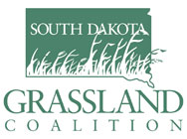
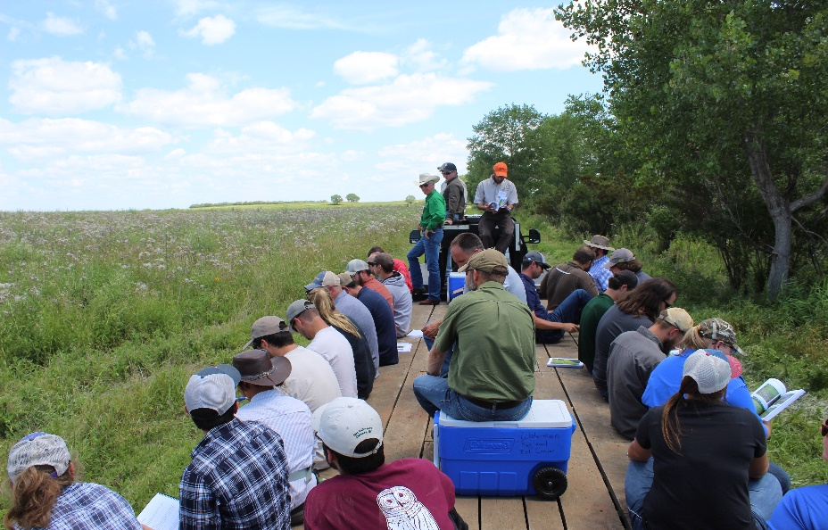

Directions to Eck site:
From Henry: North on 437th Ave (Cnty Rd 27) about 9 miles to Warner Lake Road
From Wallace: South on 437th Ave (Cnty Rd 27) about 6 miles to Warner Lake Road
- West on Warner Lake Road, then north on Crazy Man’s Lane across the lake to the building site.
Featured TOPICS:
Objectives based actions / planning for what you want
Converting ‘go-back’ fields to native species
Fire / chemicals / cover crops / grazing / species mixes
Grazing strategies / livestock integration / fence design
Soil Health: litter / soil temperature / drought/ infiltration
Wildlife habitat / native seed mixes / water quality
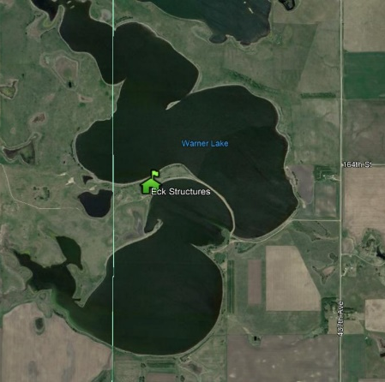
Invasive species / drought management

Registration:
Free to SD Grassland Coalition Members.
$35 for non-members (includes membership).
Email: janice.rounds@sdstate.edu or call Jan at 605-882-5140.
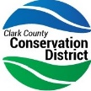
Indicate which day you would like to attend
LUNCH will not be provided: Pack your own!
Water and restrooms will be available on site.
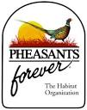
The Eck site is a multi-agency grassland restoration project. Contributors include the following:
Kopriva Angus

